**SOFTWARE ARCHITECTURE**

* Software Architecture consists of One Tier, Two Tier, Three Tier, and N-Tier architectures.
* A “tier” can also be referred to as a “layer”.
* Three layers are involved in the application namely Presentation Layer, Business Layer, and Data Layer. Let’s see each layer in detail:

**PRESENTATION LAYER:**

* It is also known as the Client layer. The top layer of an application.
* This is the layer we see when we use the software. By using this layer, we can access the web pages. The main function of this layer is to communicate with the Application layer.
* This layer passes the information which is given by the user in terms of keyboard actions, mouse clicks to the Application Layer.
* In simple words, it is to view the application.

### **APPLICATION LAYER:**

* It is also known as Business Logic Layer which is also known as the logical layer.
* It controls an application’s functionality by performing detailed processing. This layer acts as a mediator between the Presentation and the Database layer. Complete business logic will be written in this layer.
* In simple words, it is to perform operations on the application.

### **DATA LAYER:**

* The data is stored in this layer.
* The application layer communicates with the Database layer to retrieve the data.
* It contains methods that connect the database and performs required action e.g.: insert, update, delete, etc.
* In simple words, it is to share and retrieve the data.

## ****TYPES OF SOFTWARE ARCHITECTURES****

### **One Tier Architecture:**

One Tier application AKA Standalone application

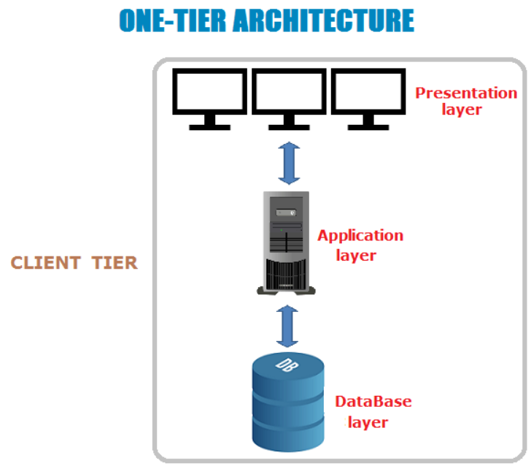

One-tier architecture has all the layers such as Presentation, Business, Data Access layers in a single software package. Applications that handle all the three tiers such as MP3 player, MS Office come under the one-tier application. The data is stored in the local system or a shared drive.

### **Two-Tier Architecture:**

Two Tier application AKA Client-Server application

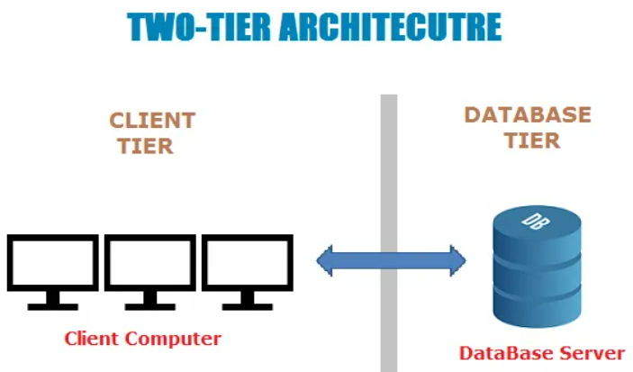

The Two-tier architecture is divided into two parts:

1. Client Application (Client Tier)  
2. Database (Data Tier)

The client system handles both Presentation and Application layers and the Server system handles the Database layer. It is also known as a client-server application. The communication takes place between the Client and the Server. The client system sends the request to the server system and the Server system processes the request and sends back the data to the Client System.

### **Three-Tier Architecture:**

Three Tier application AKA Web Based application

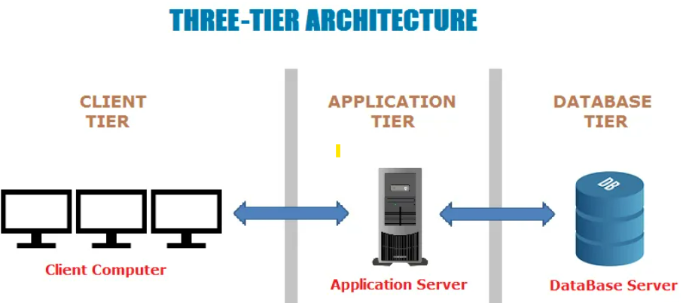

The Three-tier architecture is divided into three parts:

1. Presentation layer (Client Tier)  
2. Application layer (Business Tier)  
2. Database layer (Data Tier)

The client system handles the Presentation layer, the Application server handles the Application layer, and the Server system handles the Database layer.

**Note:** Another layer is the N-Tier application. N-Tier application AKA Distributed application. It is similar to the three-tier architecture but the number of application servers is increased and represented in individual tiers in order to distribute the business logic so that the logic will be distributed.